**Rice Production Analysis in India**

1. **Total Rice Production by Year**

SELECT

Crop_Year,

SUM(Production) AS Total_Production

FROM Crop_Yield

GROUP BY Crop, Crop_Year

HAVING Crop = 'Rice'

ORDER BY Crop_Year Desc;

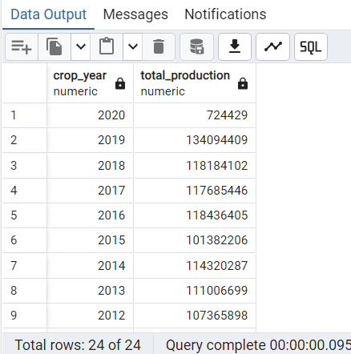

1. **Average Rice Production by State**

SELECT

State,

AVG(Production) AS AVG_Production

FROM Crop_Yield

GROUP BY Crop, State

HAVING CROP= 'Rice'

ORDER BY AVG_Production DESC;

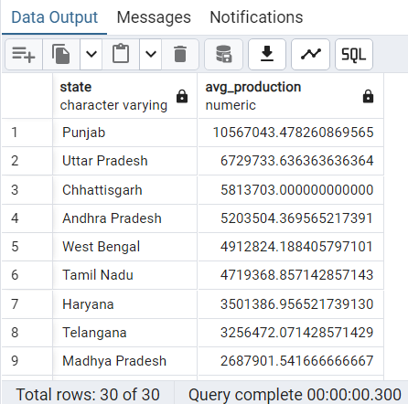

1. **Average Area used for Rice Production by State**

SELECT

State,

AVG(Area) AS AVG_Area

FROM Crop_Yield

WHERE Crop = 'Rice'

GROUP BY State

ORDER BY AVG_Area DESC;

1. **Average Rice Yield by State excluding 2020**

SELECT

State,

AVG(Yield) AS AVG_Yield

FROM Crop_Yield

WHERE Crop_Year <> 2020

GROUP BY Crop, State

HAVING CROP= 'Rice'

ORDER BY AVG_Yield DESC;

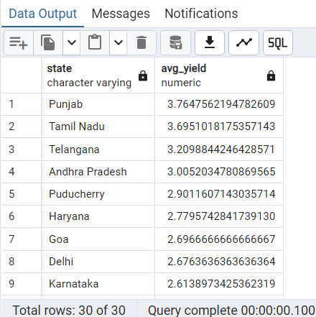

1. **Rice Production by State for 2019**

SELECT

State,

AVG(Yield) as AVG_Yield

FROM Crop_Yield

GROUP BY Crop, Crop_Year, State

HAVING Crop_Year = 2019 AND Crop = 'Rice'

ORDER BY AVG_Yield DESC;

1. **Average Yield for Rice Crops by Season**

SELECT

Season,

AVG(Yield) AS Avg_Yield

FROM Crop_Yield

WHERE Crop = 'Rice' AND Season <> 'Whole Year'

GROUP BY Season

ORDER BY Avg_Yield DESC;

1. **Fertilizer Use per Unit Production by State**

SELECT

State,

AVG(Fertilizer/Production) AS Fertilizer_per_Production

FROM Crop_Yield

GROUP BY Crop, State

HAVING CROP= 'Rice'

ORDER BY Fertilizer_per_Production;

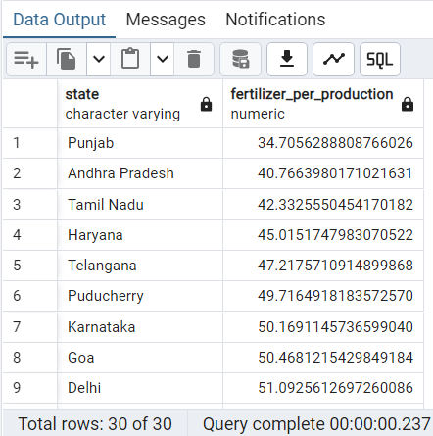

Calculating the efficiency of fertilizer used per production. Shows the State Punjab is quite efficient with fertilizer compared to other states.

1. **Pesticide Use per Unit Production by State**

SELECT

State,

AVG(Pesticide/Production) AS Pesticide_per_Production

FROM Crop_Yield

GROUP BY Crop, State

HAVING CROP= 'Rice'

ORDER BY Pesticide_per_Production;

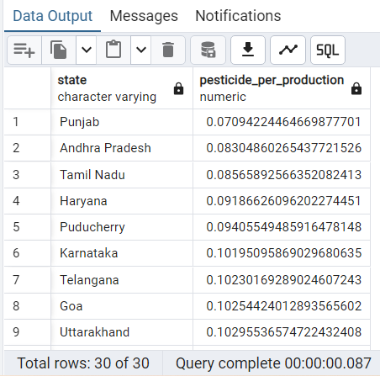

Punjab State is once again quite efficient with pesticide when compared to it’s counterparts.

**9. Average Rice Inputs, Yield State Ranks**

SELECT

State,

ROUND(AVG(yield), 2) AS AVG_yield,

ROUND(AVG(fertilizer), 2) AS AVG_fertilizer,

ROUND(AVG(pesticide), 2) AS AVG_pesticide,

ROUND(AVG(annual_rainfall), 2) AS AVG_rainfall,

ROW_NUMBER() OVER (ORDER BY AVG(Fertilizer) DESC) AS Fertilizer_Rank,

ROW_NUMBER() OVER (ORDER BY AVG(Pesticide) DESC) AS Pesticide_Rank,

ROW_NUMBER() OVER (ORDER BY AVG(Annual_Rainfall) DESC) AS Rainfall_Rank

FROM crop_yield

WHERE crop = 'Rice'

GROUP BY state

ORDER BY AVG_yield DESC;

**10. Rice Yearly Inputs with Ranks excluding 2020**

SELECT

Crop,

Crop_Year,

ROUND(AVG(Yield), 2) as Average_Yield,

ROUND(AVG(Annual_Rainfall), 2) AS Average_Rainfall,

ROW_NUMBER() OVER (ORDER BY AVG(Annual_Rainfall) DESC) AS Rainfall_Rank,

ROUND(AVG(Fertilizer), 2) as Average_Fertilizer,

ROW_NUMBER() OVER (ORDER BY AVG(Fertilizer) DESC) AS Fertilizer_Rank,

ROUND(AVG(Pesticide), 2) as Average_Pesticide,

ROW_NUMBER() OVER (ORDER BY AVG(Pesticide) DESC) AS Pesticide_Rank

FROM Crop_Yield

WHERE Crop_Year <> 2020

GROUP BY Crop, Crop_Year

HAVING CROP = 'Rice'

Inputs don’t correlate directly with higher yield

**11. Top 5 States High Input Rice**

WITH Ranked AS (

SELECT

State,

AVG(Fertilizer) AS AVG_Fertilizer,

AVG(Pesticide) AS AVG_Pesticide,

AVG(Yield) AS AVG_Yield,

ROW_NUMBER() OVER (ORDER BY AVG(Fertilizer) DESC) AS Fertilizer_Rank,

ROW_NUMBER() OVER (ORDER BY AVG(Pesticide) DESC) AS Pesticide_Rank

FROM Crop_Yield

WHERE Crop = 'Rice' AND Crop_Year <> 2020

GROUP BY State

)

SELECT *

FROM Ranked

WHERE Fertilizer_Rank <= 5 OR Pesticide_Rank <= 5;

**12. Top 5 States Rice Inputs 2019**

WITH Ranked AS (

SELECT

State,

Season,

Fertilizer,

Pesticide,

Yield,

ROW_NUMBER() OVER (ORDER BY Fertilizer DESC) AS Fertilizer_Rank,

ROW_NUMBER() OVER (ORDER BY Pesticide DESC) AS Pesticide_Rank

FROM Crop_Yield

WHERE Crop = 'Rice' AND Crop_Year = 2019

)

SELECT *

FROM Ranked

WHERE Fertilizer_Rank <= 5 OR Pesticide_Rank <= 5;

**13. Rainfall and Yield Correlation by State**

SELECT

State,

CORR(Annual_Rainfall, Yield) AS Correlation

FROM Crop_Yield

GROUP BY Crop, State

HAVING Crop = 'Rice'

ORDER BY Correlation DESC;

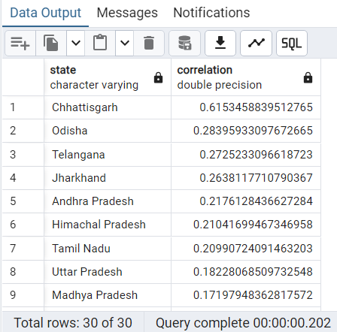

Chhattisgarh shows strong rainfall-yield link

**14. High Input and High Yield States**

SELECT

State,

AVG(Fertilizer) AS AVG_Fertilizer,

AVG(Pesticide) AS AVG_Pesticide,

AVG(Yield) AS AVG_Yield

FROM Crop_Yield

WHERE Crop = 'Rice'

GROUP BY State

HAVING

AVG(Yield) > (SELECT AVG(Yield) FROM Crop_Yield WHERE Crop = 'Rice')

AND AVG(Fertilizer) > (SELECT AVG(Fertilizer) FROM Crop_Yield WHERE Crop = 'Rice')

AND AVG(Pesticide) > (SELECT AVG(Pesticide) FROM Crop_Yield WHERE Crop = 'Rice')

ORDER BY AVG_Yield DESC;

**15. High Yield and Low Input States**

SELECT

State,

AVG(Fertilizer) AS AVG_Fertilizer,

AVG(Pesticide) AS AVG_Pesticide,

AVG(Yield) AS AVG_Yield

FROM Crop_Yield

WHERE Crop = 'Rice'

GROUP BY State

HAVING

AVG(Yield) > (SELECT AVG(Yield) FROM Crop_Yield WHERE Crop = 'Rice')

AND AVG(Fertilizer) < (SELECT AVG(Fertilizer) FROM Crop_Yield WHERE Crop = 'Rice')

AND AVG(Pesticide) < (SELECT AVG(Pesticide) FROM Crop_Yield WHERE Crop = 'Rice')

ORDER BY AVG_Yield DESC;

As per the above two tables, more states achieve high yield with low inputs.

**16. Rice Quartile Analysis Low Input High Yield**

SELECT

Crop,

State,

Crop_Year,

Season,

Annual_Rainfall,

Fertilizer,

Pesticide,

Yield

FROM CROP_YIELD

WHERE CROP = 'Rice'

AND Fertilizer < ( SELECT PERCENTILE_CONT(0.25) WITHIN GROUP (ORDER BY FERTILIZER) AS Fertilizer_25th_Percentile FROM CROP_YIELD WHERE CROP = 'Rice')

AND Pesticide < (SELECT PERCENTILE_CONT(0.25) WITHIN GROUP (ORDER BY PESTICIDE) AS Pesticide_25th_Percentile FROM CROP_YIELD WHERE CROP = 'Rice')

AND Yield > (SELECT PERCENTILE_CONT(0.75) WITHIN GROUP (ORDER BY Yield) AS Yield_75th_Percentile FROM CROP_YIELD WHERE CROP = 'Rice')

ORDER BY Yield DESC;

**17. Comparrison Rice Inputs, Output Punjab and Tamil Nadu**

SELECT

State,

AVG(Yield) AS avg_yield,

AVG(Fertilizer / Area) AS avg_fertilizer_per_ha,

AVG(Pesticide / Area) AS avg_pesticide_per_ha,

AVG(Production / Fertilizer) AS production_per_unit_fertilizer,

AVG(Production / Pesticide) AS production_per_unit_pesticide,

AVG(Annual_Rainfall) AS avg_annual_rainfall,

AVG(Area) AS avg_area,

AVG(Production) AS avg_production,

SUM(Production) AS total_production

FROM Crop_Yield

WHERE Crop = 'Rice'

AND State IN ('Punjab', 'Tamil Nadu')

GROUP BY State;



Tamil Nadu appears to be more input-intensive than Punjab in rice production, using more fertilizer and pesticide per hectare. However, this higher input use does not result in greater efficiency, as Tamil Nadu has a slightly lower average yield (3.70 t/ha) compared to Punjab (3.76 t/ha), and lower production per unit of fertilizer and pesticide. Despite receiving significantly more rainfall, Tamil Nadu underperforms Punjab in input efficiency. Punjab also cultivates rice on a much larger scale, which may contribute to economies of scale. Its average annual production is more than twice that of Tamil Nadu, and total rice production is nearly double, highlighting Punjab’s stronger performance both in efficiency and scale.